# C:\Users\James\AppData\Local\Microsoft\Windows\INetCache\Content.Word\1510864_10152222978819882_1653651865_n.jpg

Test and Integration plan

#### Software Team, James Oatley

# Document Control

|  |  |  |  |  |
| --- | --- | --- | --- | --- |
| Version Number | Modified By | Date | Section(s) Modified | Comments |
| *1.0* | *Unknown* | *Unknown* | *All* | *N/A* |
| *1.1* | *J. Oatley* | *06/04/2014* | *All* | *Re-formatted.* |
|  |  |  |  |  |
|  |  |  |  |  |
|  |  |  |  |  |
|  |  |  |  |  |
|  |  |  |  |  |
|  |  |  |  |  |
|  |  |  |  |  |
|  |  |  |  |  |
|  |  |  |  |  |
|  |  |  |  |  |

Contents

[1 Introduction 1](#_Toc384467469)

[1.1 Heading 2 1](#_Toc384467470)

[1.1.1 Heading 3 1](#_Toc384467471)

# Test and Integration Plan

## 1.1 Introduction

The testing and integration phase when constructing a product will determine the final quality of the product. Hence coming up with a concrete testing and integration plan for each iteration is crucial and essential. Appendix 1 shows the flow chart on how the testing and integration plan is to be executed.

## 1.2 Testing and Integration Plan

As mentioned in the Quality Assurance Manual, testing of each feature or user stories should be taking place during its implementation phase. There will be separate test plans run by the developer and subsequently, the testing department. The developers’ tests will centre on whatever they deem important for code development. After the code has been delivered to the testing department, another set of tests will be run to check that the code performs the function required for the user story.

However only after Iteration 1, once all individual user stories of the iteration have been tested, will integration commence. This is done so as to provide the entire group with a basic module and in further iterations, for any pair team that have finished their subsequent user stories could integrate that user stories into the basic module.

After any integration has been made to the basic module, the pair team would have to test the newly integrated module with the deterministic test plan so as to ensure that the integration did not break the existing product. If the newly integrated module did not achieve the pre-determined outcome of the DTP, that user story module will be removed and referred back to the pair team for further investigation.

The user story test plan used will be tailored to fit the iteration being developed. However, the iterations will follow a similar plan to that mentioned above where the module is tested as it is developed, tested by the testing department, integration testing is carried out and if any problems arise during integration, the module is removed then the code revised.

## 1.3 Conclusion

Having the Iteration Test Plan and DTP ensures that the product being produced meets the requirement and of high quality standard. Since Spoon is following the AGILE principles, the tests inside the Iteration Test Plan and DTP might change over time. Therefore, communication between the software and testing sides must be established.

# Appendix

## Appendix 1



**Iteration 1**

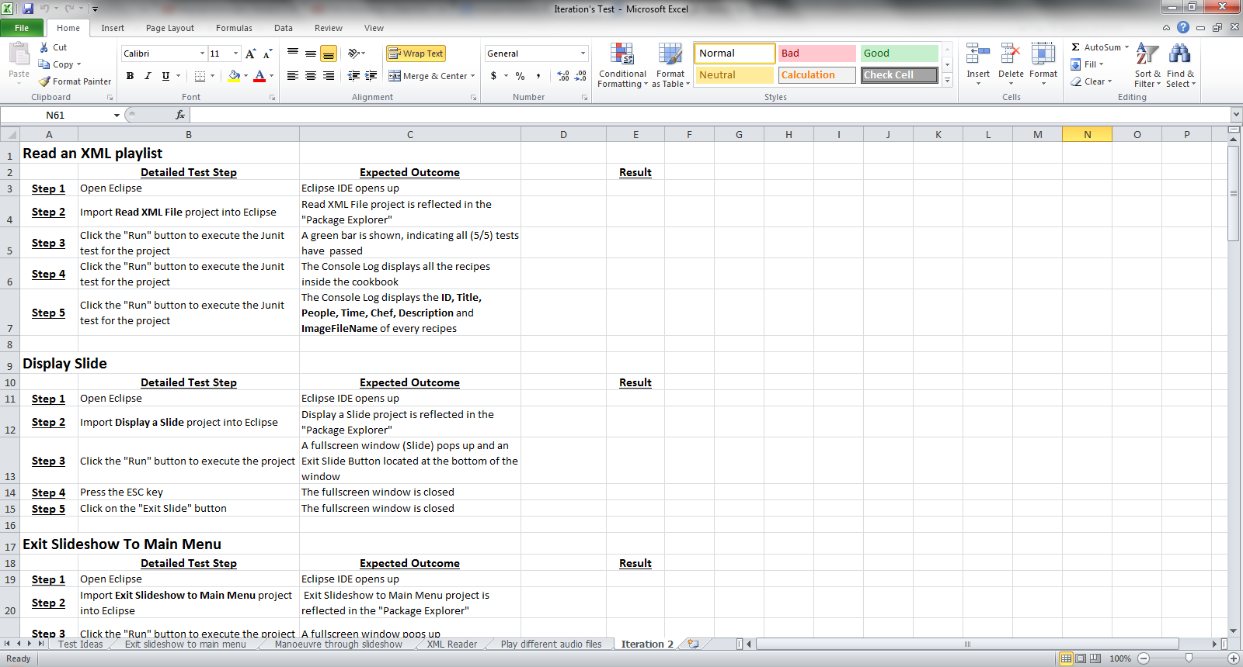

**Formulate test plan for each user stories**



**Consolidate and integrate each user stories and perform test plan according**



**Test the integrated module with the deterministic test plan**